**Vehicle Sales Summary**

**## TOTAL REVENUE ##**

SELECT SUM(SALES) AS Total_Revenue from hotelman.vehicle_sales_v2;



**## AVERAGE ORDER VALUE ##**

SELECT SUM(SALES)/ COUNT(DISTINCT ORDERNUMBER) as Avg_Order_Value from hotelman.vehicle_sales_v2;



**## TOTAL VEHICLES SOLD ##**

SELECT SUM(QUANTITYORDERED) as Total_Vehicles_Sold from hotelman.vehicle_sales_v2;



**## TOTAL ORDERS ##**

SELECT COUNT(DISTINCT ORDERNUMBER) as Total_Orders from hotelman.vehicle_sales_v2;

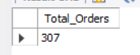

**## AVERAGE VEHICLES PER ORDER ##**

SELECT SUM(QUANTITYORDERED)/ COUNT(DISTINCT ORDERNUMBER) as AVG_VEHICLES from hotelman.vehicle_sales_v2;



**## MONTHLY TRENDS FOR ORDERS ##**

SELECT MONTHNAME(ORDERDATE) as Month_Name, COUNT(DISTINCT ORDERNUMBER) as Total_Orders from hotelman.vehicle_sales_v2

GROUP BY Month_Name

ORDER BY Total_Orders DESC;

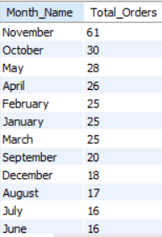

**## MONTHLY TRENDS FOR ORDERS ##**

SELECT MONTH(ORDERDATE) as _Month, MONTHNAME(ORDERDATE) as Month_Name, COUNT(DISTINCT ORDERNUMBER) as Total_Orders from hotelman.vehicle_sales_v2

GROUP BY _Month, Month_Name

ORDER BY _Month ASC;

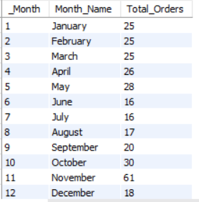

**## YEARLY TRENDS FOR ORDERS ##**

SELECT YEAR(ORDERDATE) as year_no, COUNT(DISTINCT ORDERNUMBER) as Total_Orders from hotelman.vehicle_sales_v2

GROUP BY year_no

ORDER BY year_no ASC;

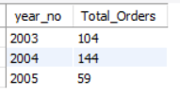

**## PERCENTAGE OF SALES BY PRODUCT LINE ##**

SELECT PRODUCTLINE, CAST(SUM(SALES) AS DECIMAL(10,2)) as TOTAL_SALES, CAST(SUM(SALES) * 100 / (SELECT SUM(SALES) from hotelman.vehicle_sales_v2) AS DECIMAL(10,2)) as PCT from hotelman.vehicle_sales_v2

GROUP BY PRODUCTLINE

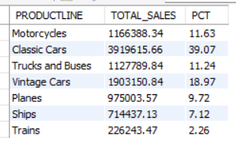

**## PERCENTAGE OF SALES BY PRODUCT LINE ## QUARTER 1**

SELECT PRODUCTLINE, CAST(SUM(SALES) AS DECIMAL(10,2)) as TOTAL_SALES, CAST(SUM(SALES) * 100 / (SELECT SUM(SALES) from hotelman.vehicle_sales_v2 WHERE QTR_ID = 1) AS DECIMAL(10,2)) as PCT from hotelman.vehicle_sales_v2

WHERE QTR_ID = 1

GROUP BY PRODUCTLINE

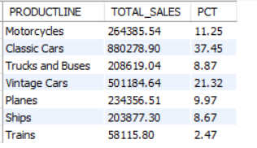

**## PERCENTAGE OF SALES BY PRODUCT LINE ## QUARTER 1**

SELECT PRODUCTLINE, CAST(SUM(SALES) AS DECIMAL(10,2)) as TOTAL_SALES, CAST(SUM(SALES) * 100 / (SELECT SUM(SALES) from hotelman.vehicle_sales_v2 WHERE MONTH_ID = 1 or MONTH_ID = 2 or MONTH_ID = 3) AS DECIMAL(10,2)) as PCT from hotelman.vehicle_sales_v2

WHERE MONTH_ID = 1 or MONTH_ID = 2 or MONTH_ID = 3

GROUP BY PRODUCTLINE

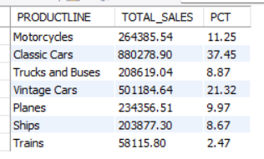

**TOP AND BOTTOM PRODUCT LINES**

**## TOP 3 PRODUCT LINES BASED ON REVENUE ##**

SELECT PRODUCTLINE, CAST(SUM(SALES) AS DECIMAL(10,2)) AS Total_Revenue FROM hotelman.vehicle_sales_v2

GROUP BY PRODUCTLINE

ORDER BY Total_Revenue DESC LIMIT 3

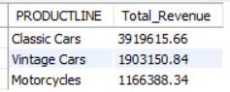

**## BOTTOM 3 PRODUCT LINES BASED ON REVENUE ##**

SELECT PRODUCTLINE, CAST(SUM(SALES) AS DECIMAL(10,2)) AS Total_Revenue FROM hotelman.vehicle_sales_v2

GROUP BY PRODUCTLINE

ORDER BY Total_Revenue ASC LIMIT 3

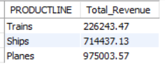

**## TOP 3 PRODUCT LINES BASED ON QUANTITY ORDERED ##**

SELECT PRODUCTLINE, CAST(SUM(QUANTITYORDERED) AS DECIMAL(10,2)) AS QUANTITY_ORDERED FROM hotelman.vehicle_sales_v2

GROUP BY PRODUCTLINE

ORDER BY QUANTITY_ORDERED DESC LIMIT 3

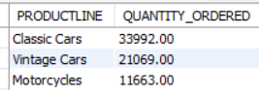

**## BOTTOM 3 PRODUCT LINES BASED ON QUANTITY ##**

SELECT PRODUCTLINE, CAST(SUM(QUANTITYORDERED) AS DECIMAL(10,2)) AS QUANTITY_ORDERED FROM hotelman.vehicle_sales_v2

GROUP BY PRODUCTLINE

ORDER BY QUANTITY_ORDERED ASC LIMIT 3

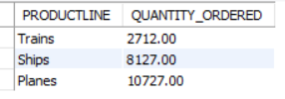

**## TOP 3 PRODUCT LINES BASED ON ORDERS ##**

SELECT PRODUCTLINE, COUNT(DISTINCT ORDERNUMBER) AS Total_Orders FROM hotelman.vehicle_sales_v2

GROUP BY PRODUCTLINE

ORDER BY Total_Orders DESC LIMIT 3

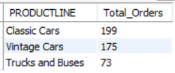

**## BOTTOM 3 PRODUCT LINES BASED ON ORDERS ##**

SELECT PRODUCTLINE, COUNT(DISTINCT ORDERNUMBER) AS Total_Orders FROM hotelman.vehicle_sales_v2

GROUP BY PRODUCTLINE

ORDER BY Total_Orders ASC LIMIT 3

